

**Table of Contents**

1 Objective of This Experiment 3

2 Procedure 3

2.1 Introduction 3

2.2 Waveforms of voltages and currents at α = 60 4

2.3 Harmonic spectrums of the input/output currents and voltages at α = 60 5

2.3.1 The harmonic spectrum of the input current/voltage 5

2.3.2 The harmonic spectrum of the output current/voltage 6

2.4 Summary of the recorded/calculated data. 7

4 Calculations and Questions 7

Q1- 7

Q2- 10

5 Conclusions 10

**List of Figures**

Figure 1:- The figure shows a 3phase thyristor AC controller 3

Figure 2:- The figure shows the waveforms of the input voltage and current at α =60 4

Figure 3:- The figure shows the waveforms of the output voltage and current at α =60 4

Figure 4:- The figure shows the harmonics of the input current at α =60 5

Figure 5:- The figure shows the harmonics of the input voltage at α =60 5

Figure 6:- The figure shows the harmonics of the output current at α =60 6

Figure 7:- The figure shows the harmonics of the output voltage at α =60 6

Figure 8:- The figure shows a plot between the firing angle and the output voltage 8

Figure 9:- The figure shows a plot between the firing angle and the power factor 8

Figure 10:- The figure shows a plot between the firing angle and the reactive power 9

Figure 11:- The figure shows a plot between the firing angle and the efficiency. 9

**List of Tables**

Table 1:- The table shows the data for the 3phase thyristor AC controller. 7

# 1 Objective of This Experiment

The main objectives of this experiment are to investigate the performances of a 3phase AC-AC power electronic converters (AC Controllers) when supplying a 3phase induction motor. The target performances includes; the harmonic contents on the input and output sides of the converter, the input power factor, and the output power factor.

# 2 Procedure

## 2.1 Introduction

The figure below shows the circuit of a 3phase thyristor AC controller which is constructed using the thyristor module; an input voltage of 120V was used. The firing angles are generated by the firing angle module. The data acquisition module (DAM) was used to observe and record; the input current, active power, reactive power, and also the output DC voltage, current, active power, and reactive power. We took the above recordings at different firing angles; 0, 20, 40, 60, 80, 100, and 110; table 1 below shows a summary of the recorded and calculated data. At α = 60, we observed and recorded the waveforms of the input/output currents and voltages as well as their harmonic spectrum.

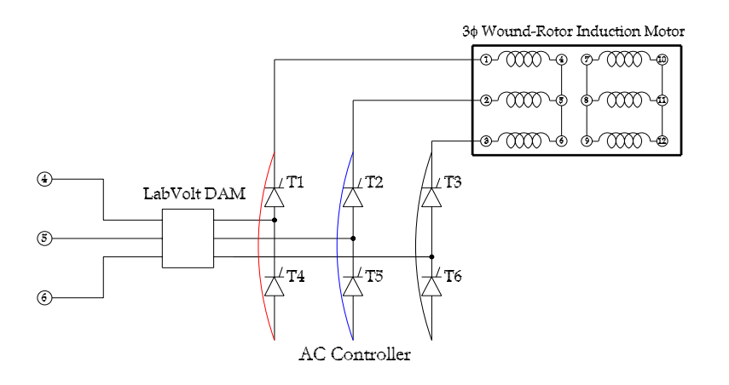

Figure 1:- The figure shows a 3phase thyristor AC controller

## 2.2 Waveforms of voltages and currents at α = 60

Figures 2 and 3 shows a representation of the input/output voltage and current in the time domain.

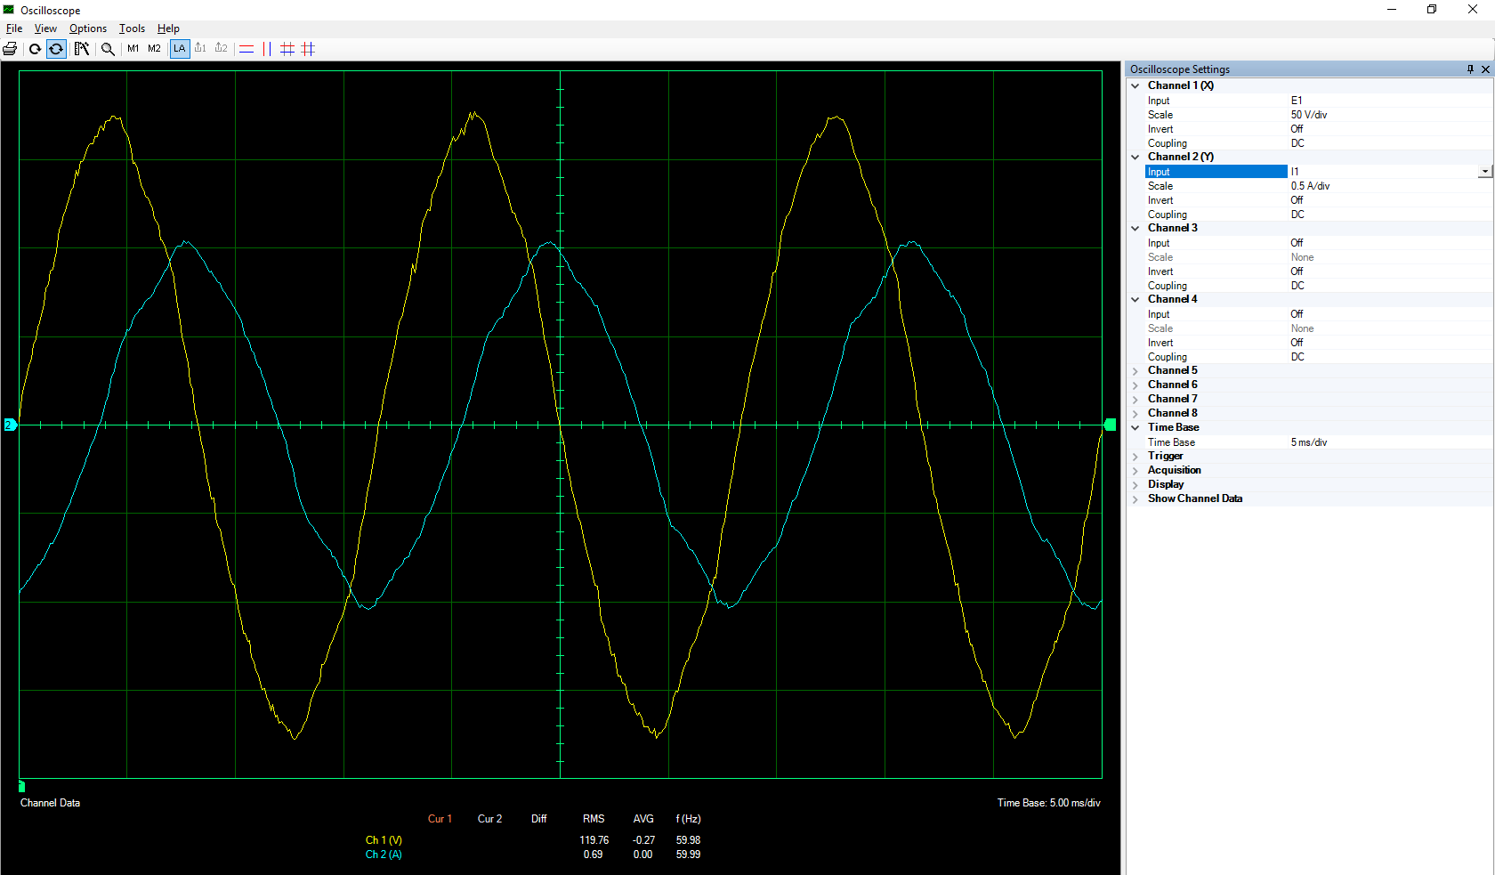

Figure 2:- The figure shows the waveforms of the input voltage and current at α =60

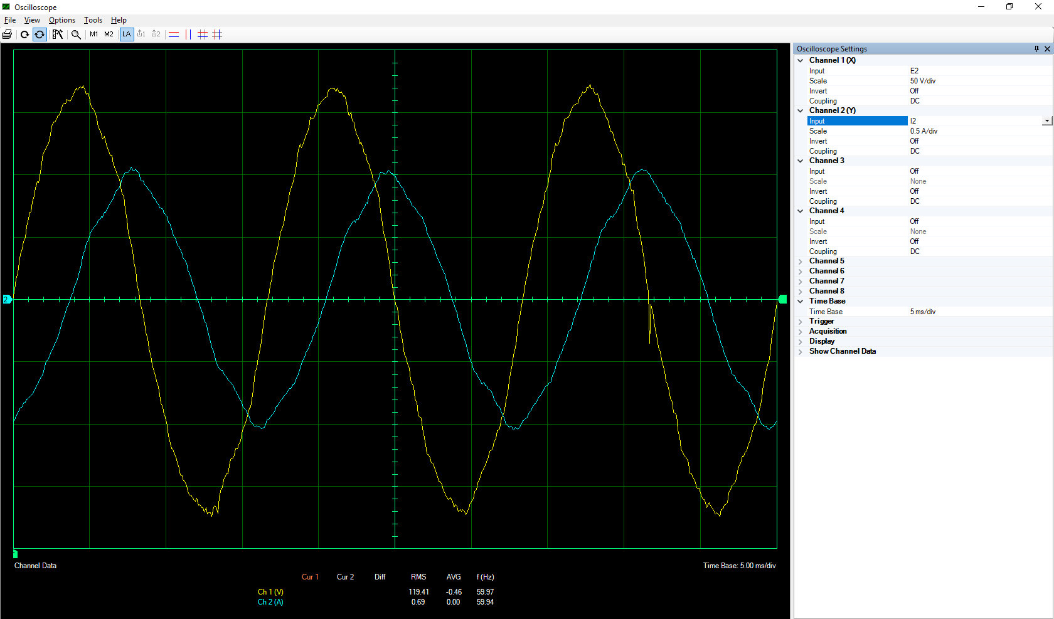

Figure 3:- The figure shows the waveforms of the output voltage and current at α =60

## 2.3 Harmonic spectrums of the input/output currents and voltages at α = 60

### 2.3.1 The harmonic spectrum of the input current/voltage

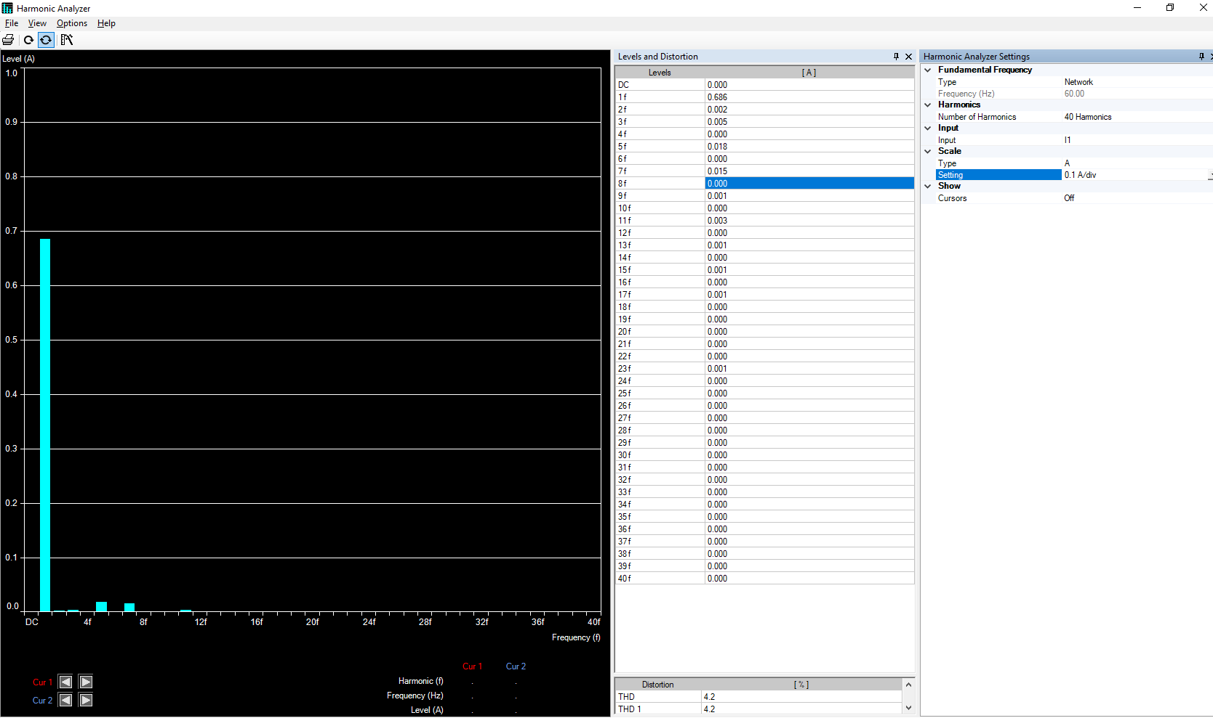

Figure 4:- The figure shows the harmonics of the input current at α =60

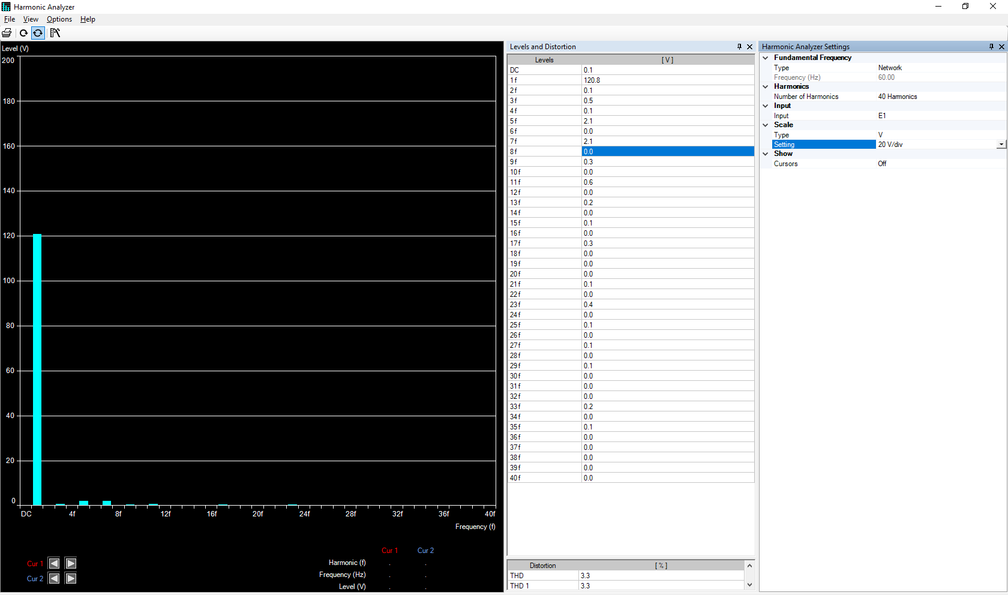

Figure 5:- The figure shows the harmonics of the input voltage at α =60

### 2.3.2 The harmonic spectrum of the output current/voltage

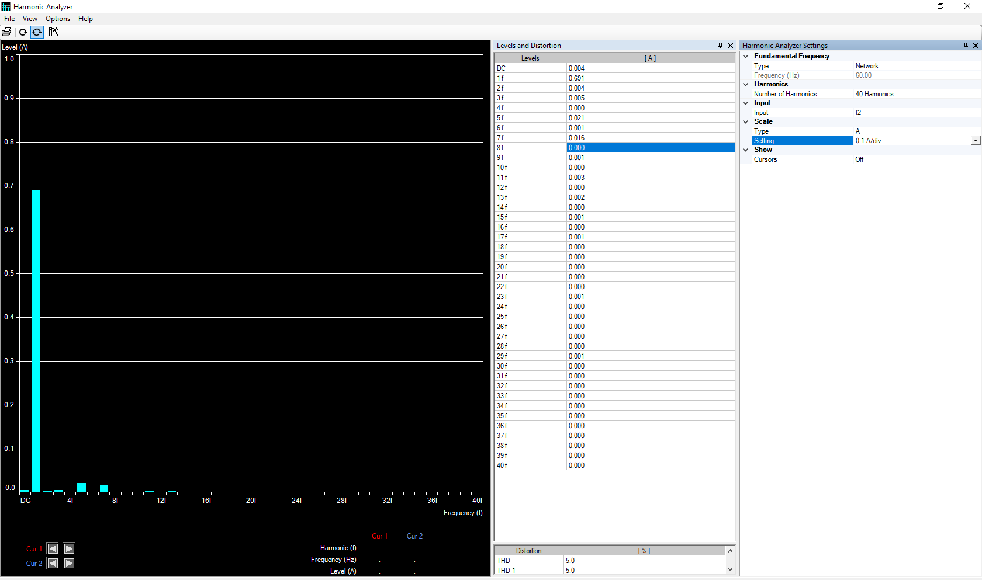

Figure 6:- The figure shows the harmonics of the output current at α =60

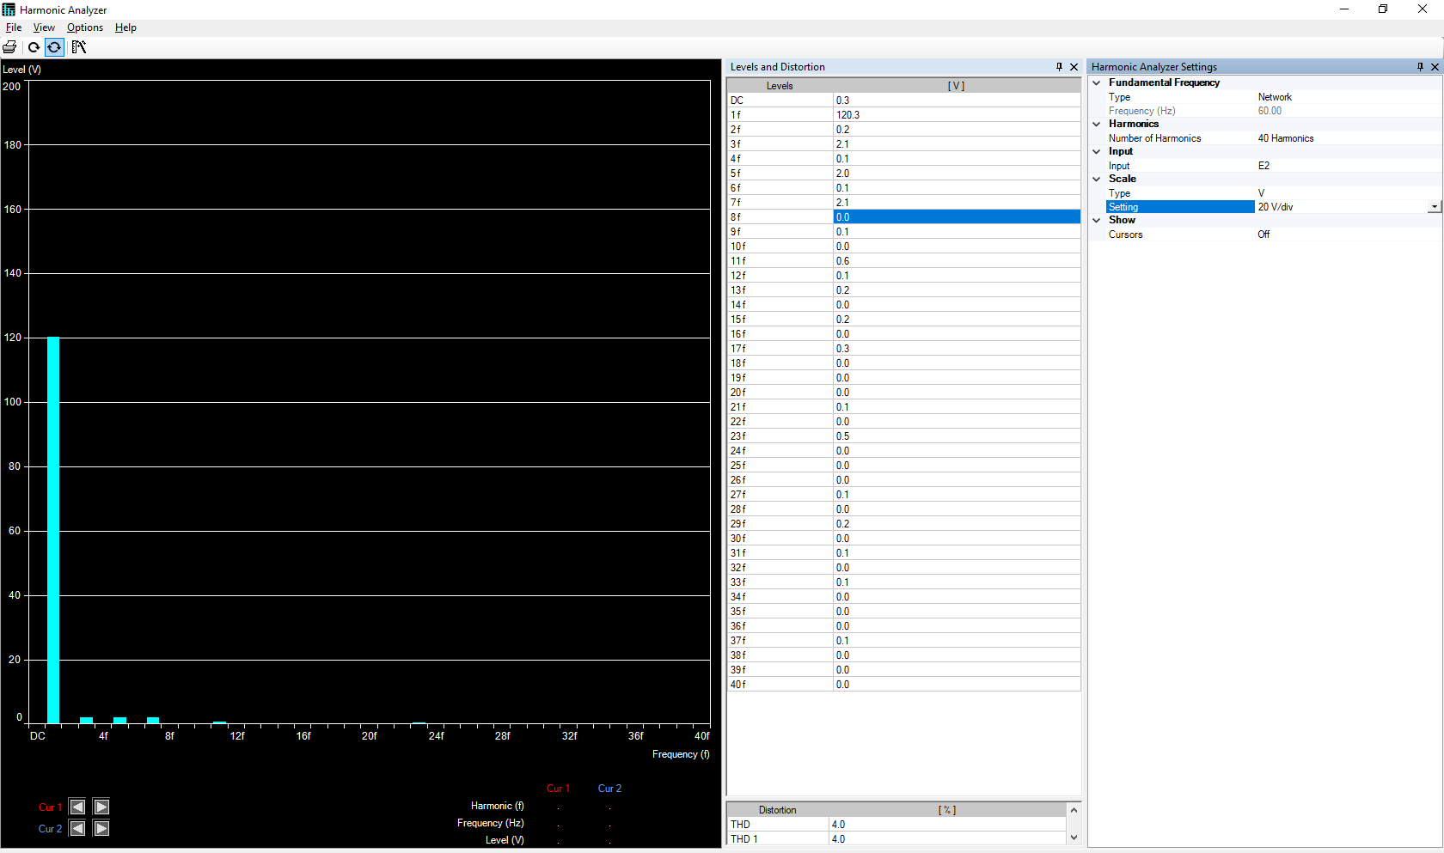

Figure 7:- The figure shows the harmonics of the output voltage at α =60

## 2.4 Summary of the recorded/calculated data.

|  |  |  |  |  |  |  |  |  |  |
| --- | --- | --- | --- | --- | --- | --- | --- | --- | --- |
| α | (Ia)in | Pin | Qin | Vo | (Ia)out | Po | Qo | PFo | η |
| 0 | 0.685 | 17.35 | 80.47 | 119.2 | 0.686 | 16.54 | 80.27 | 0.2018 | 95.3314 |
| 20 | 0.688 | 17.01 | 80.97 | 119.3 | 0.690 | 16.01 | 80.49 | 0.1951 | 94.1211 |
| 40 | 0.685 | 16.89 | 79.97 | 119.2 | 0.684 | 16.09 | 79.77 | 0.1977 | 95.2635 |
| 60 | 0.685 | 16.70 | 79.78 | 118.9 | 0.684 | 15.97 | 80.11 | 0.1955 | 95.6287 |
| 80 | 0.690 | 16.29 | 81.18 | 120 | 0.691 | 15.46 | 80.91 | 0.1877 | 94.9048 |
| 100 | 0.543 | 12.36 | 64.74 | 102.2 | 0.549 | 11.33 | 52.12 | 0.2124 | 91.6667 |
| 110 | 0.284 | 6.89 | 30.50 | 54.66 | 0.300 | 6.532 | 10.89 | 0.5144 | 94.8041 |

Table 1:- The table shows the data for the 3phase thyristor AC controller.

# 4 Calculations and Questions

Q1- Using the data from Table 1, we created graphs to show the relationship between the firing angle α and Vo, PFo, Qo, and η.

Figure 8:- The figure shows a plot between the firing angle and the output voltage

Figure 9:- The figure shows a plot between the firing angle and the power factor

Figure 10:- The figure shows a plot between the firing angle and the reactive power

Figure 11:- The figure shows a plot between the firing angle and the efficiency.

Q2- Here are some comments on the relationships shown above

The output voltage is almost 120 V until α=80 but it has been decreased after that because the amount of voltage that the thyristors conduct decreases, and accordingly the motor speed is reduced. We have a very bad power factor due to the inductive motor and it’s almost 0.2 and the reactive power is 80 VAR. In addition, the efficiency is almost the same until we reach α=80.

After α=80 the voltage decreases, which in turn will decrease the reactive power, and accordingly the power factor will increase slightly. Regarding output voltage deduction, the output power is decreased so the efficiency will decrease too.

At α=120, the output voltage, the reactive power, and the active power decreases but the difference between P and Q are less than before that’s the reason the power factor and efficiency increased.

# 5 Conclusions

We can derive from this experiment that by using AC-AC controller, we can adjust and change the output voltage and frequency to our desired one. According to the waveforms, the distortion that are obvious in them are due to the switching elements. Also, considering the spectrums, the inductive motor caused harmonics.